**Activity: Configure a Flat schema with multiple sources**

**Introduction**

In the previous lesson, you gained knowledge of the different data models used in Power BI for data analysis. The simplest form of a data model is the Flat schema.

In the exercise, you must apply your knowledge of data models to build and configure a Flat schema in Power BI.

* You'll walk through the steps to create a Flat schema in Power BI using the Adventure Works dataset.
* The goal is to merge two different tables of datasets into a single consolidated dataset to build a Flat schema that can be utilized for data analysis and visualization.

**Case study**

Adventure Works’ system saves sales records into a dataset with attributes like **product**, **category**, and **unit price**. On the other hand, the records of Adventure Works sales team employees are stored in a separate table called **Salespersons**.

Adventure Works wants to analyze the performance of its sales team. So, it needs to create a data model in Power BI that accurately and consistently organizes and integrates sales data alongside the records of its sales team. You can help the company to develop this data model as a Flat schema.

The company provides you with an Excel file called *AdventureWorksDataSet,* available for download below. The file contains two tables called **Sales** and **Salespersons**. You must combine both tables into a consolidated dataset containing all relevant fields related to the company's sales data and sales team.

You must load this dataset into Power BI and develop it as a Flat schema. Be sure to combine the data tables and configure the model to ensure that Adventure Works can use it to make informed decisions.

[Adventure Works Dataset](https://d3c33hcgiwev3.cloudfront.net/7aIPU578T82Suc0gSJd-ng_a206d303eb204f8ea21fdb4ea6f872e1_Adventure-Works-Dataset.xlsx?Expires=1709942400&Signature=DrphFw9u8w7dhxm4hsvjlI89pk4g6ZMvqqRKBDSxPWGro7UFCOjixWnbW1lLlwBH2rTD-gm0TrzsmP47BJx5C5sT6drcmljheFCNH~6CRVPPp~Kdf8TbCAMiB3oqOH1cNsUa~QYi~Jp1gNiuDO8aheWx6de8xYi9t~6Q6axyBRo_&Key-Pair-Id=APKAJLTNE6QMUY6HBC5A" \t "_blank)

[XLSX File](https://d3c33hcgiwev3.cloudfront.net/7aIPU578T82Suc0gSJd-ng_a206d303eb204f8ea21fdb4ea6f872e1_Adventure-Works-Dataset.xlsx?Expires=1709942400&Signature=DrphFw9u8w7dhxm4hsvjlI89pk4g6ZMvqqRKBDSxPWGro7UFCOjixWnbW1lLlwBH2rTD-gm0TrzsmP47BJx5C5sT6drcmljheFCNH~6CRVPPp~Kdf8TbCAMiB3oqOH1cNsUa~QYi~Jp1gNiuDO8aheWx6de8xYi9t~6Q6axyBRo_&Key-Pair-Id=APKAJLTNE6QMUY6HBC5A" \t "_blank)

**Step 1: Download the Excel Files.**

* Download and open the Microsoft Excel workbook **AdventureWorksDataset.xlsx**. The workbook contains two worksheets named **Sales** and **Salespersons**, as depicted in the screenshots below.

**Tip:** You can download the workbook from this page by selecting the above Excel file.

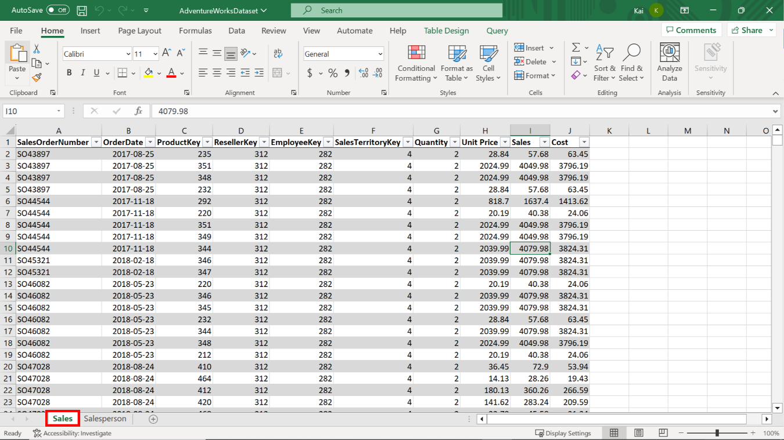

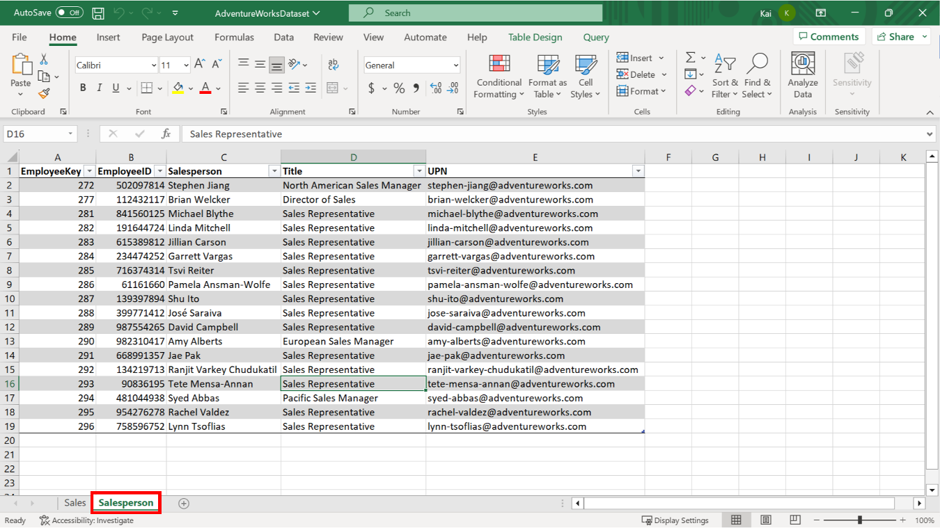

**Step 2: Get data from the Excel workbook.**

1. Import the data from the Excel sheet into Power BI.
2. Open a preview of the table in the **Preview pane**.

**Tip:** You can import data using the **Get Data** drop-down menu.

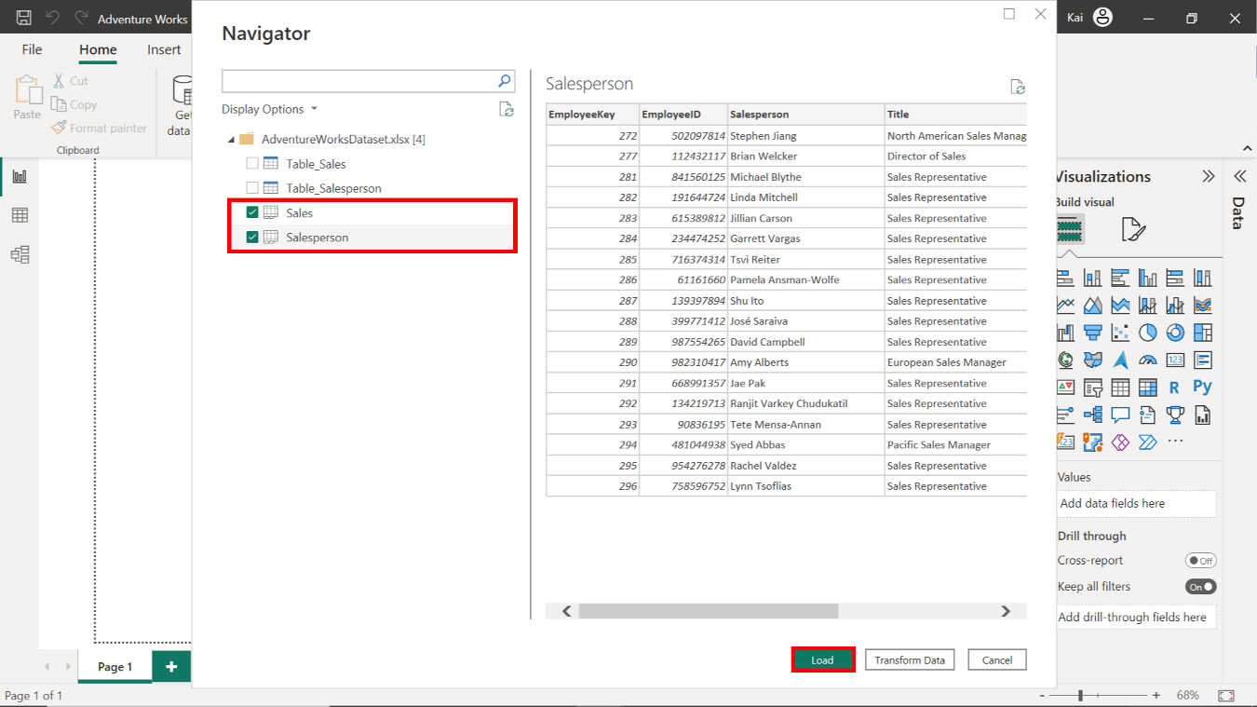

**Step 3: Load the tables from your data source and merge the tables into one dataset.**

1. Identify and remove all duplicate values in the **SalesOrderNumber** column in the **Sales** dataset.

**Tip:** You can remove duplicate values using the **Remove Duplicates** feature.

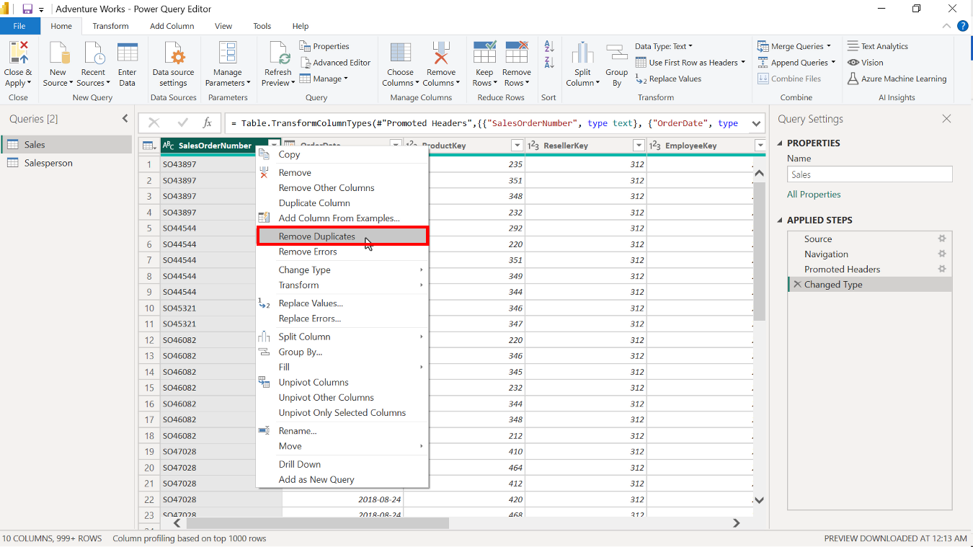

1. Identify common columns with matching or similar values in both tables. These values can be used to merge both tables.

**Tip:** You can check the columns related to **employees** at both tables.

1. In the **Query Editor**, select the **Sales** table and click on **Merge queries**. This action opens the **Merge** dialog box in which you can configure the merge options. You must select the second table to merge with, ensuring you match the column and **Join Kind**.

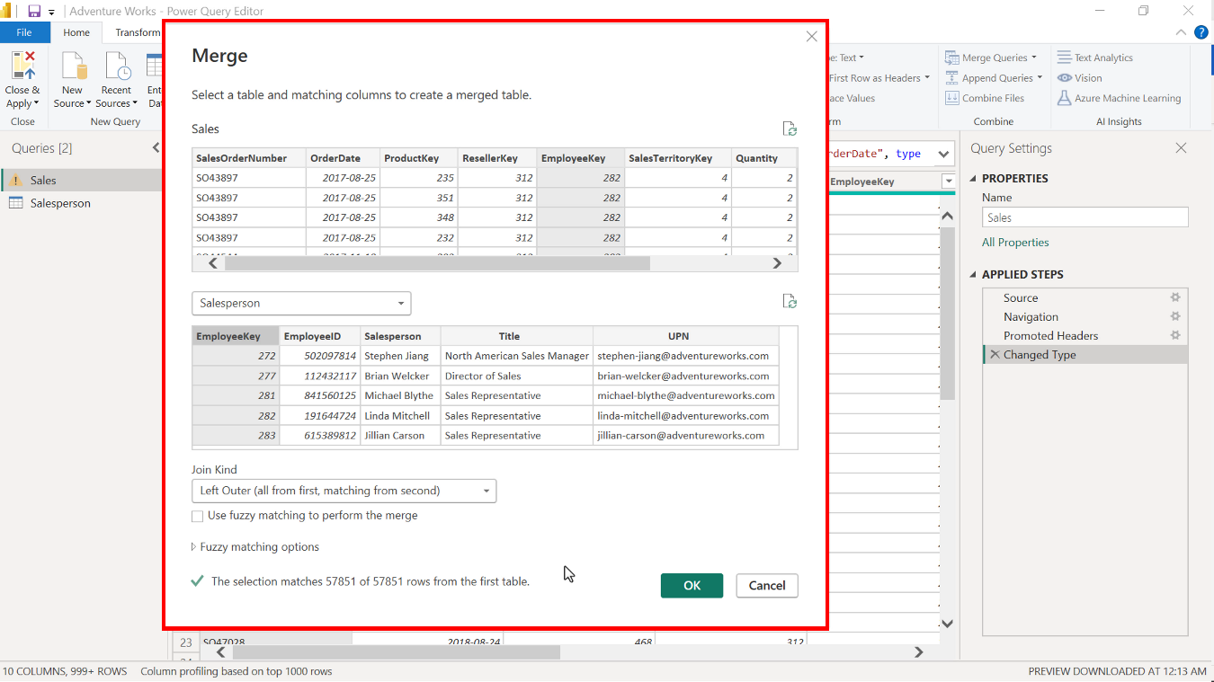

1. The merged table is displayed as a column at the end of the table. Select the **column** to expand the merged table. Select **Employee ID**, **Salesperson**, and **Title** columns to expand and select **OK**.
2. After merging the tables, you can delete the **Salesperson** table from the model, as this table has been integrated with the **Sales** table as a Flat schema.

**Tip:** You can combine tables using **Merge queries** in the **Power Query** editor and the **Left outer** join type.

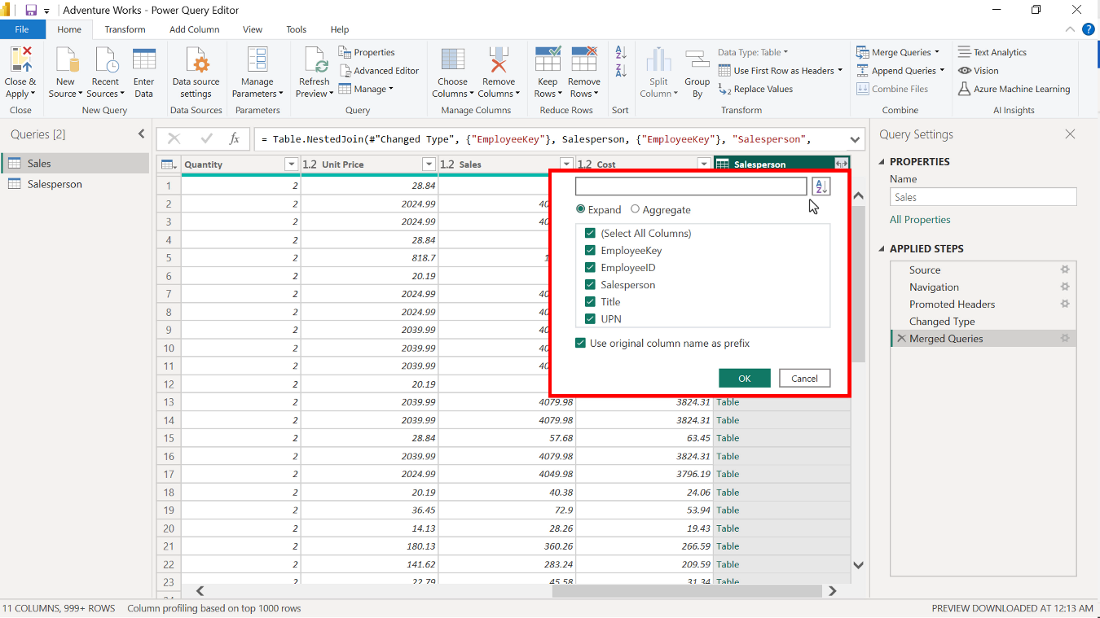

**Step 4: Configure table and column properties.**

1. Configure the table properties by renaming the table **Adventure Works Sales Data** and adding a brief description of the table in Power BI desktop.

**Tip:** You can configure table properties in the **Model view** of the Power BI desktop.

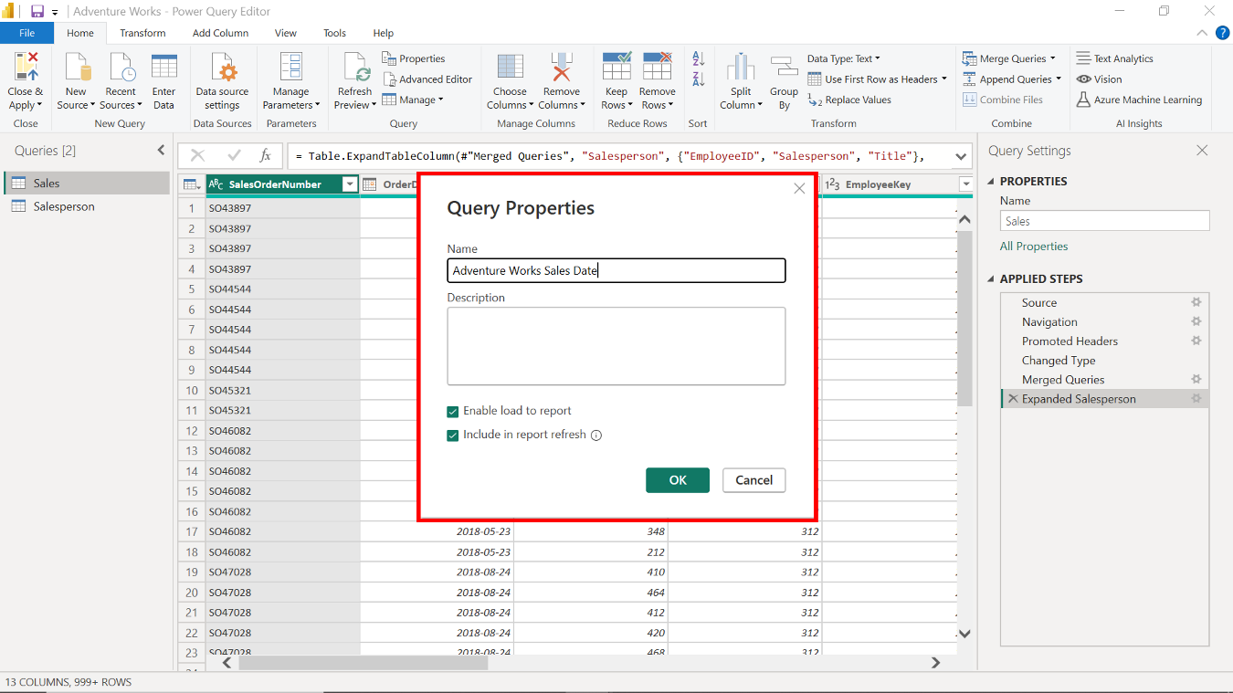

1. Configure column properties as follows:

* Merge queries autogenerate column names. Rename the columns as follows:
* **Saleperson.EmployeeID** to **Employee ID**,
* **Salesperson.Salesperson** to **Salesperson**
* and **Salesperson.Title** to **Title**.
* Change and format the data types of the columns.
* Add additional information to the columns.

**Tip:** You can configure column properties both in the **Power Query editor** and in the **Model view** of the Power BI desktop.

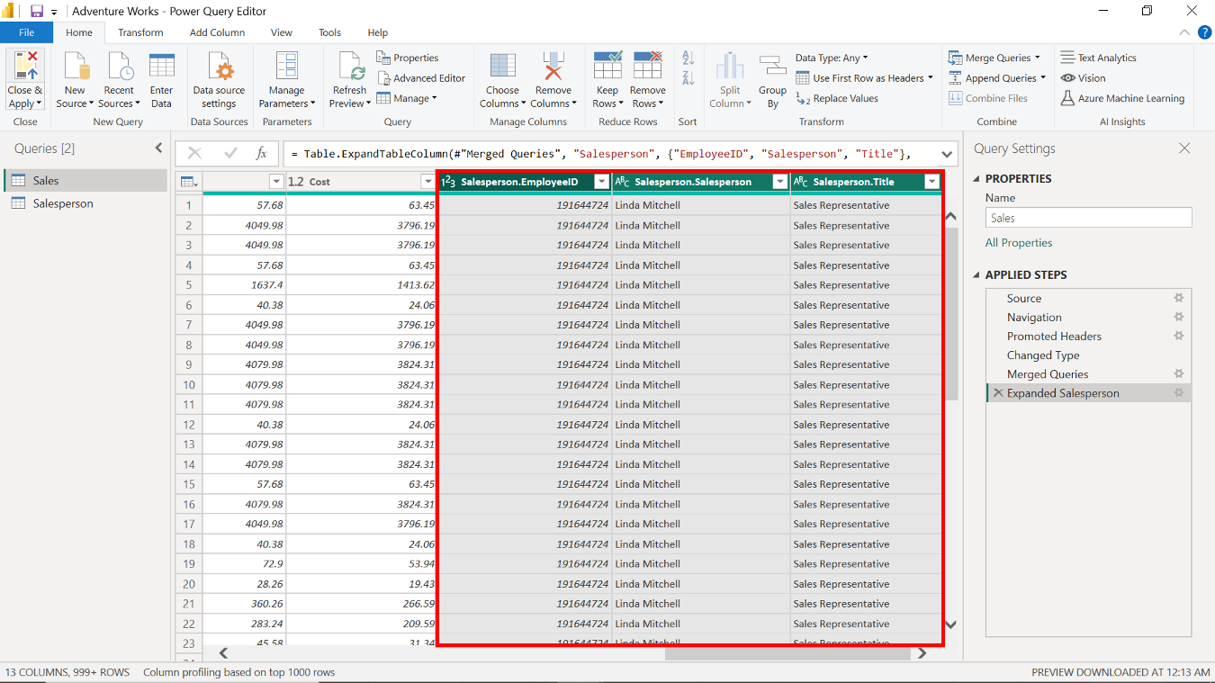

**Step 5: Save the Power BI project.**

* Save your Flat schema Power BI project to your local machine.

**Tip:** Select an appropriate project name and folder path for your schema.

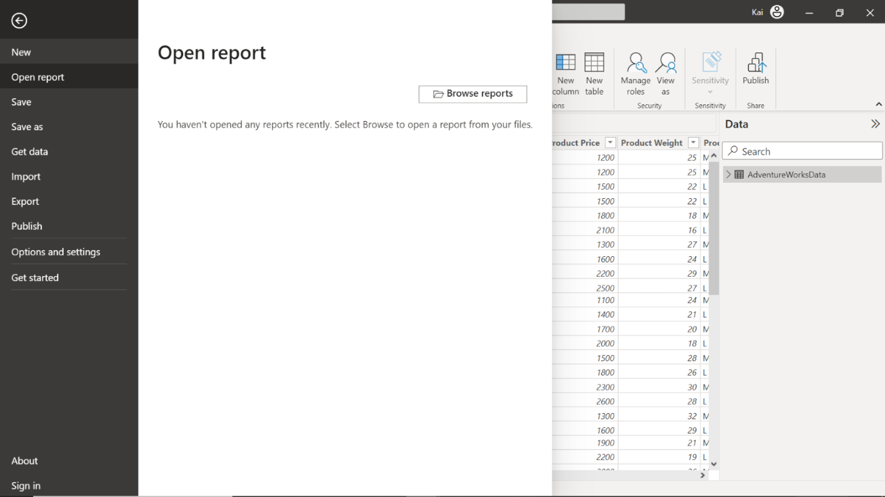

**Conclusion**

By merging tables in Power BI, you can create a consolidated data table from disparate sources to build a Flat schema. While a Flat schema can be convenient for some scenarios, it is important to note that it may not be suitable for complex data relationships or larger datasets. In such cases, a normalized schema with multiple tables and defined relationships is a better option to ensure performance and flexibility.